Shift register implementation.

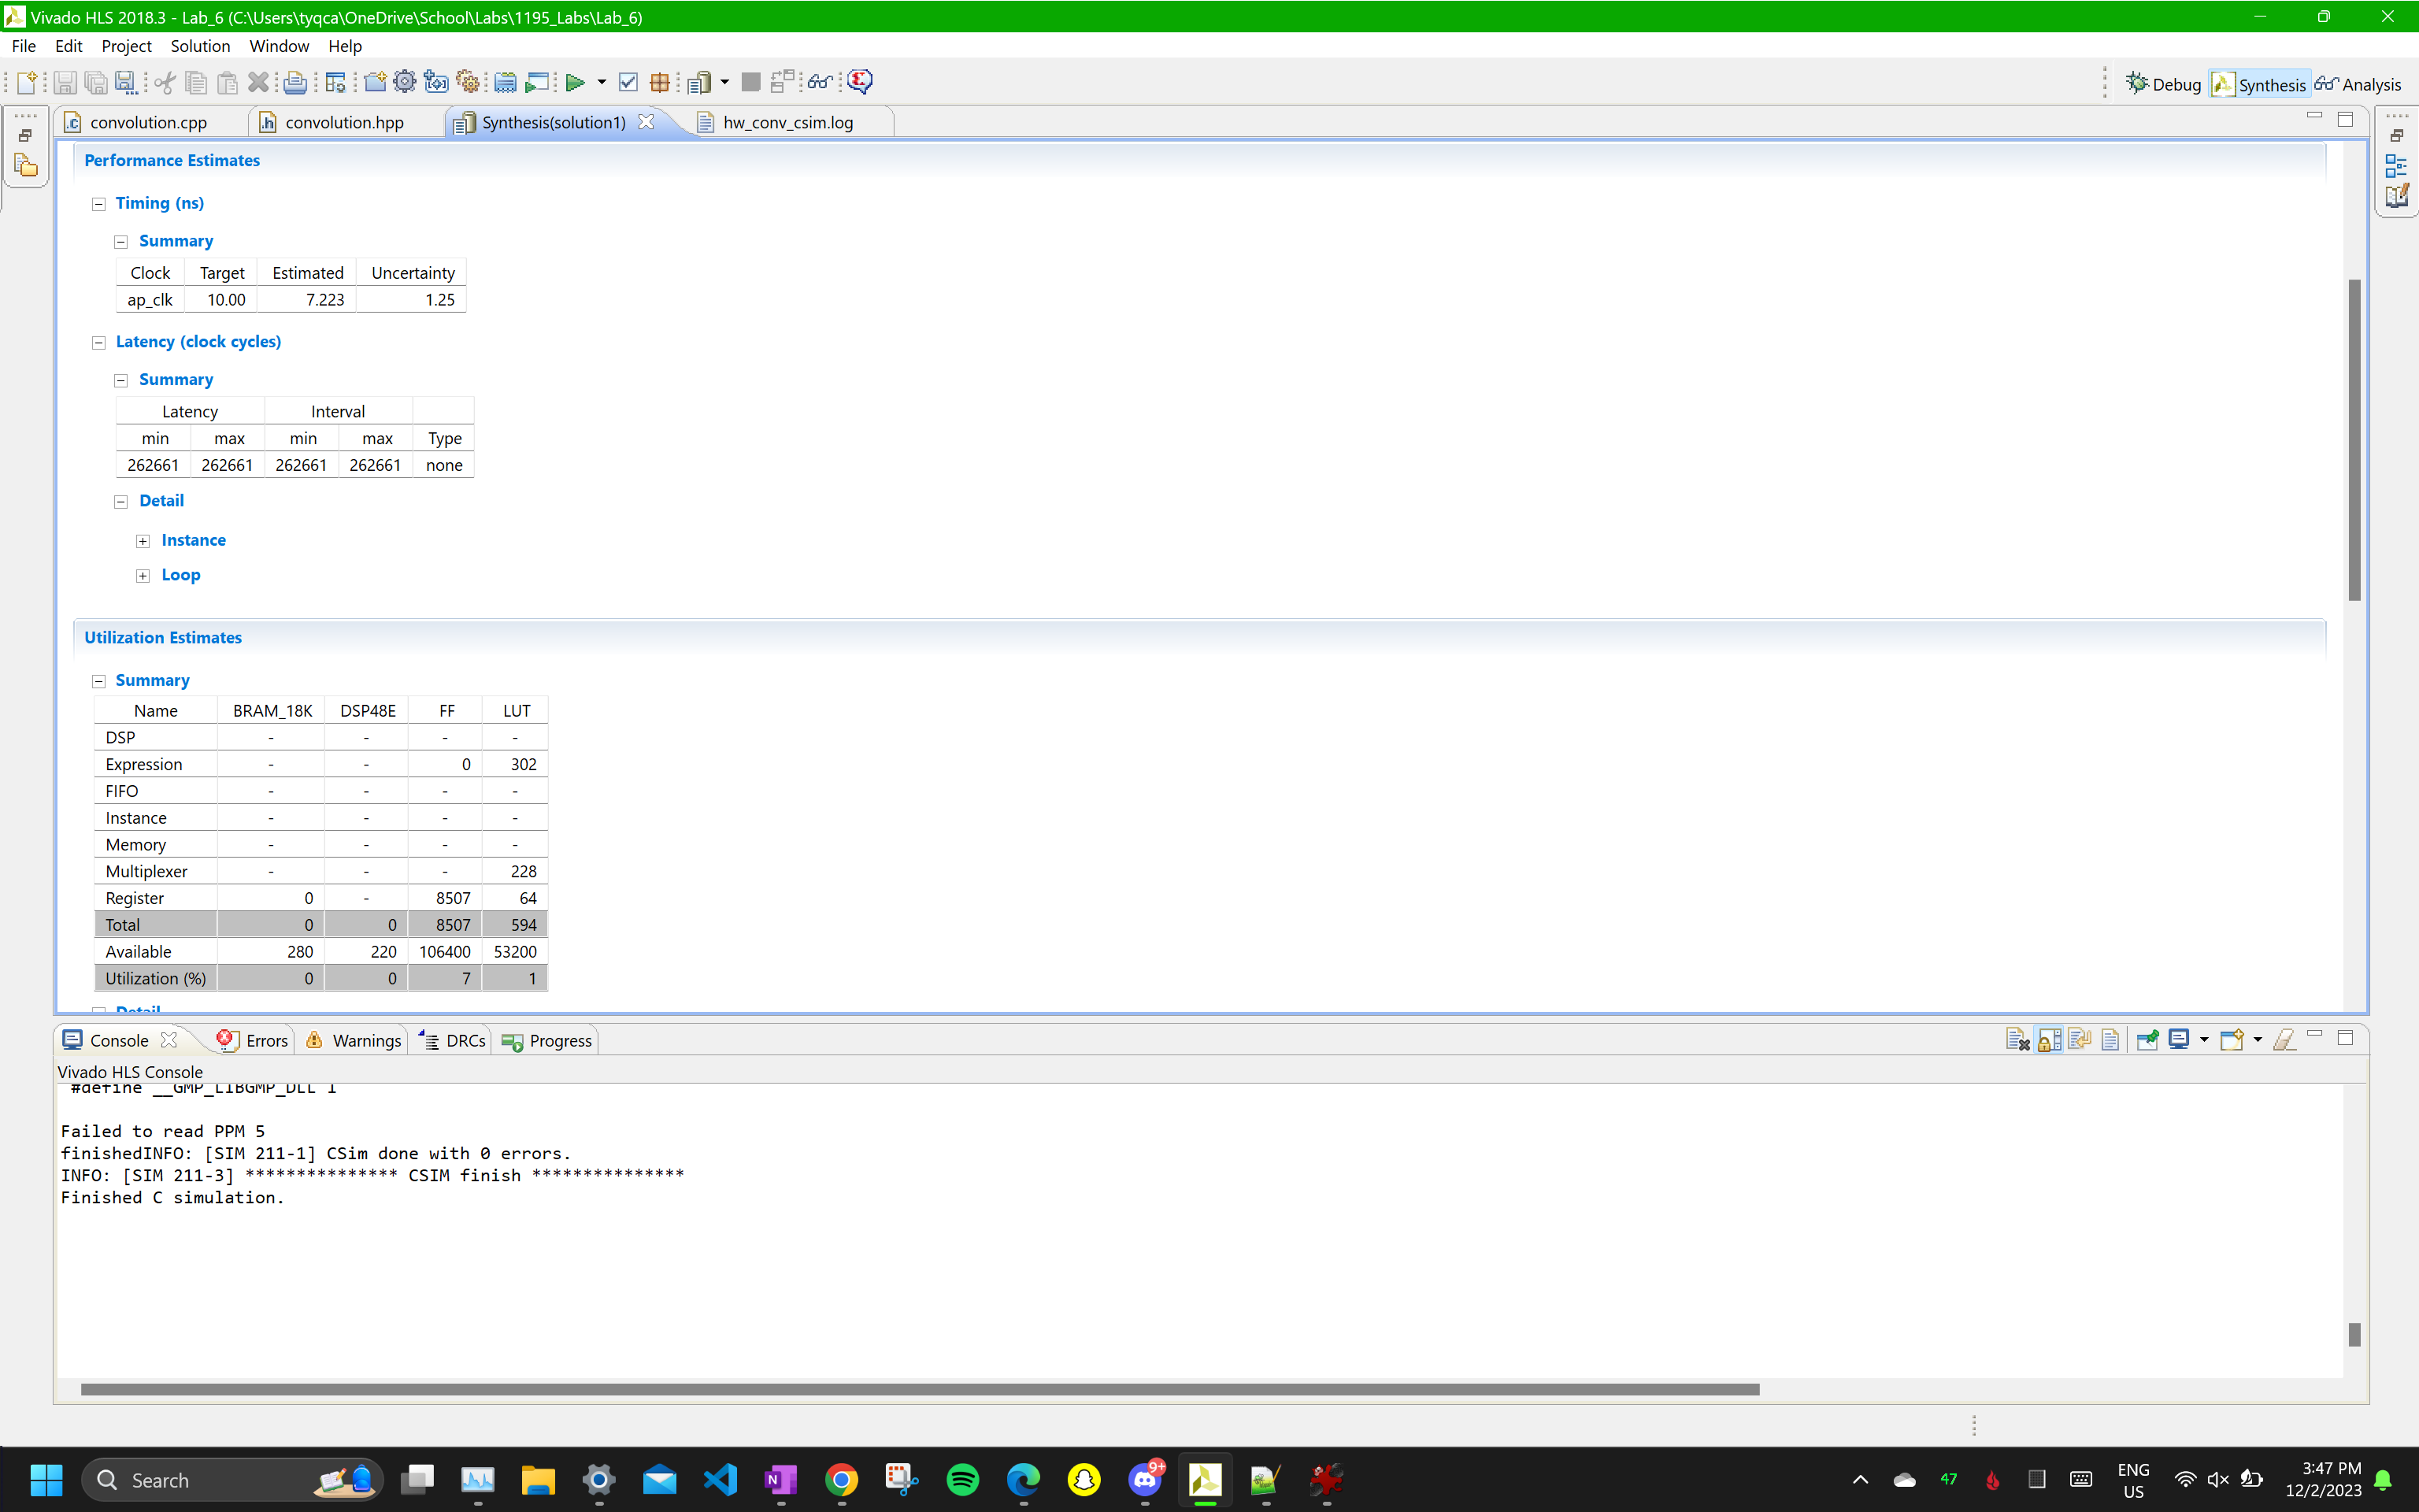

Changed the lbuf partition dim = 0

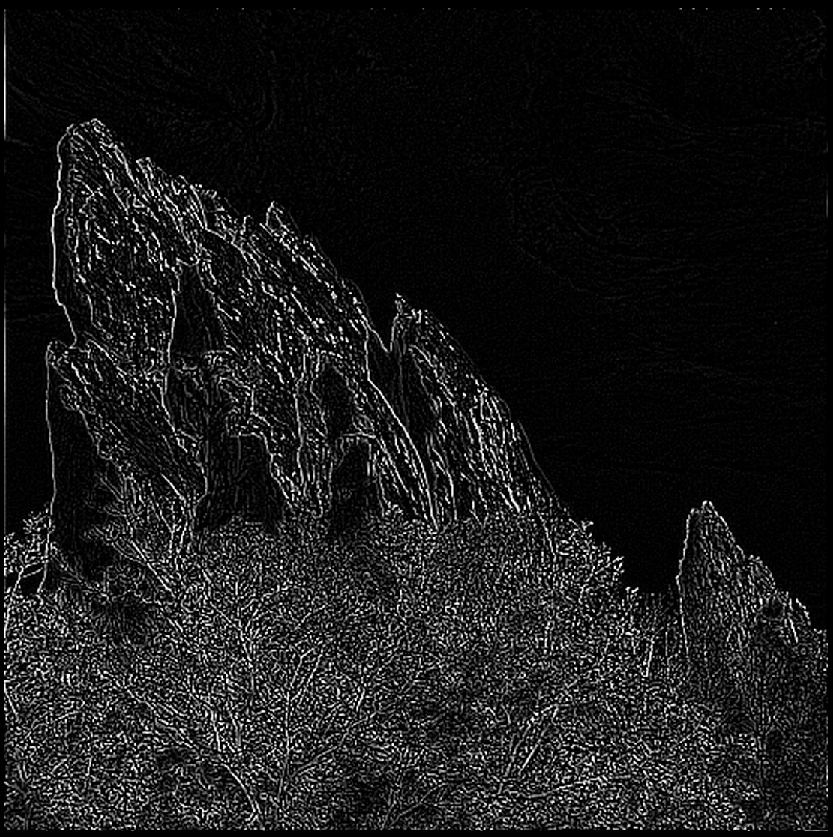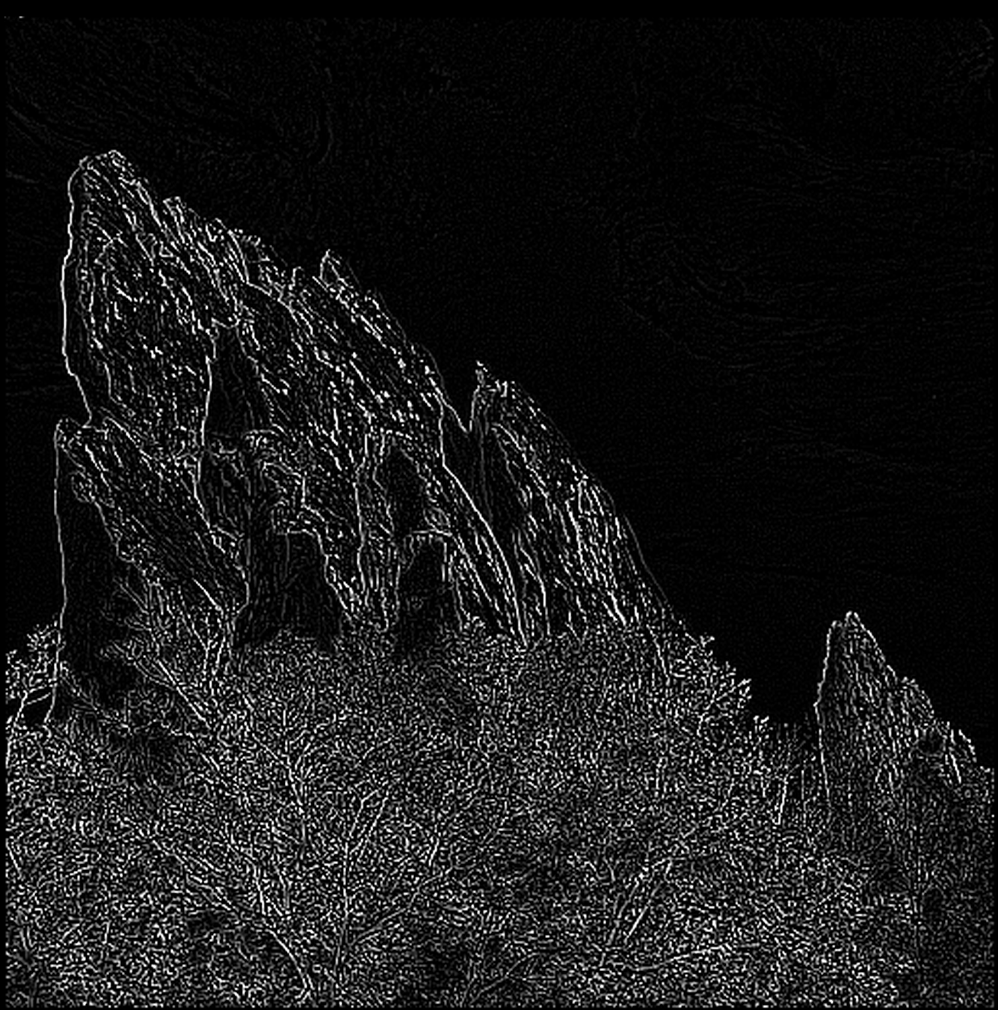

Output_hw.pgm shift register output_sw.pgm shift register

Ring buffer implementation

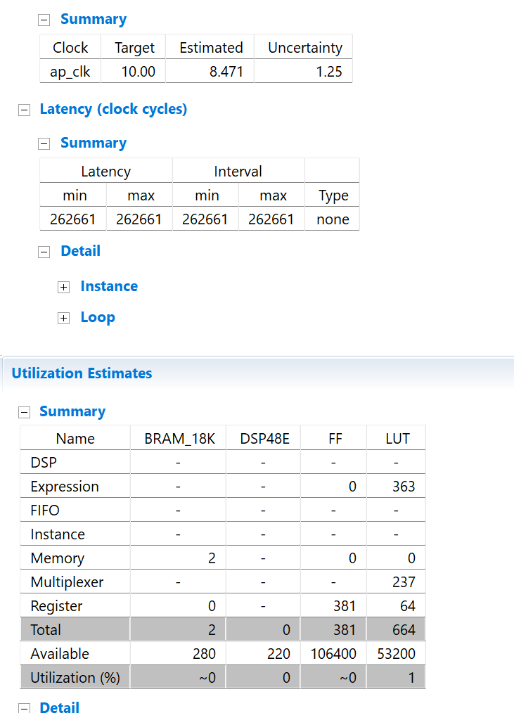

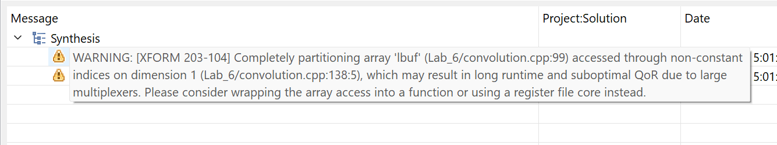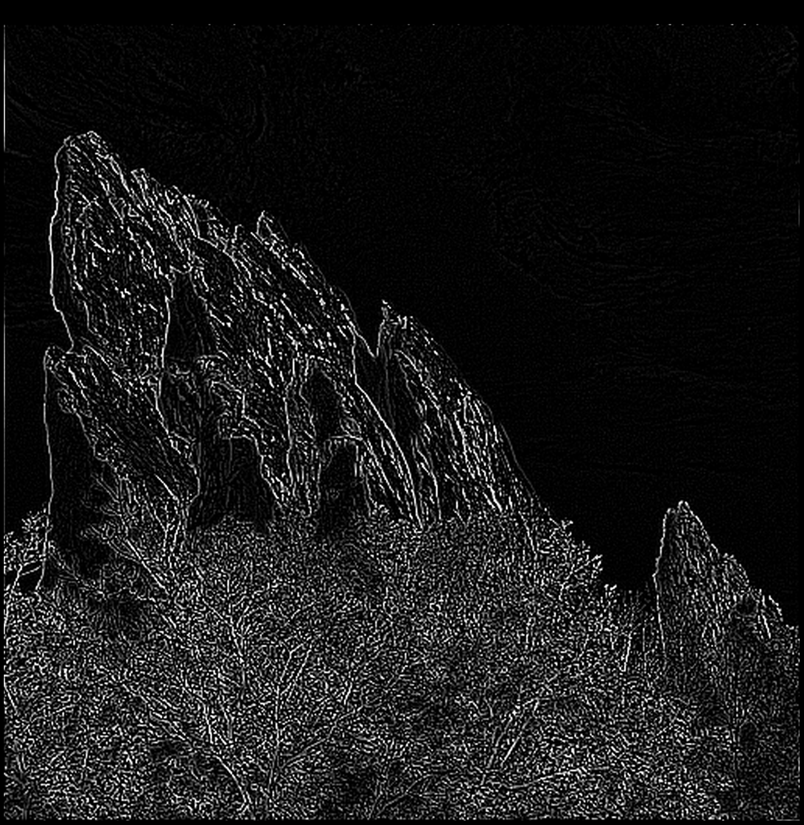`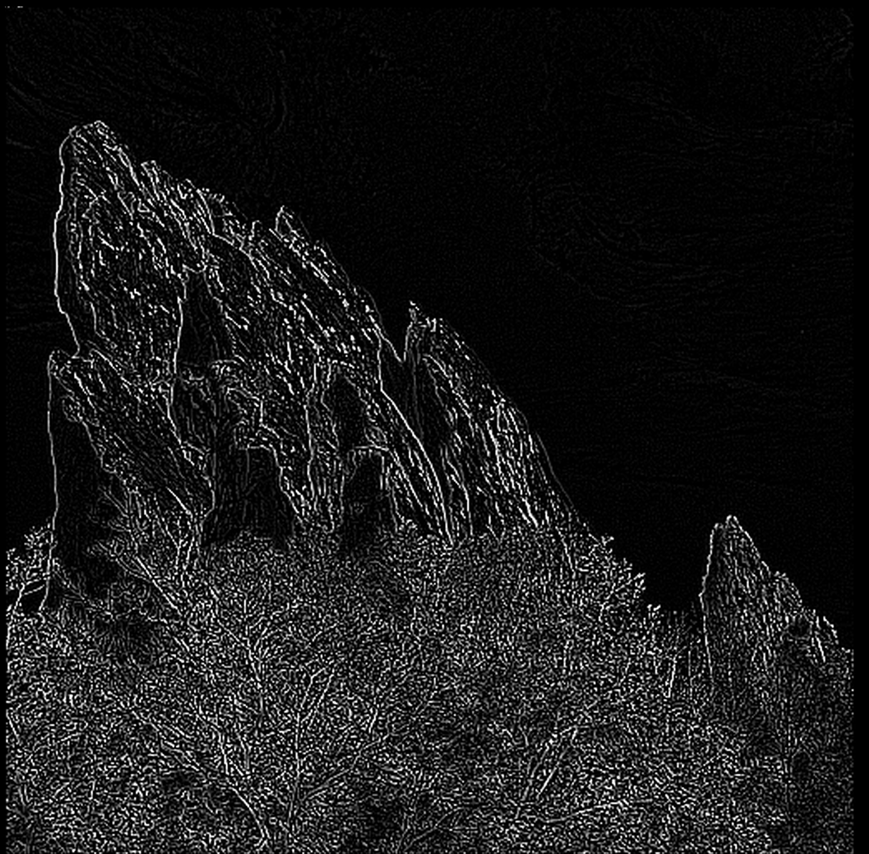

Output_hw.pgm ring buffer Output_sw.pgm ring buffe

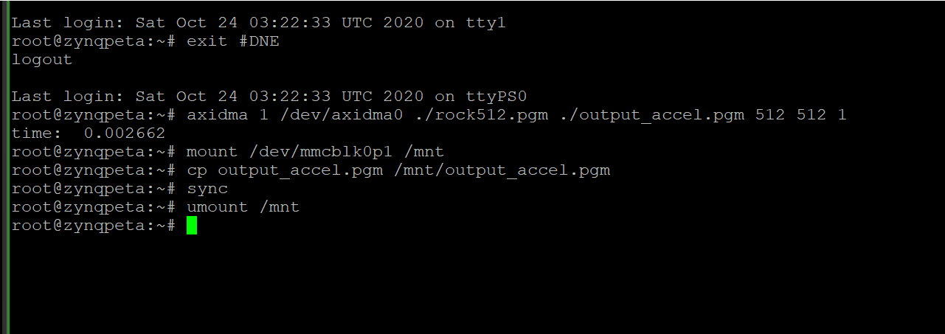

screenshot of puTTy

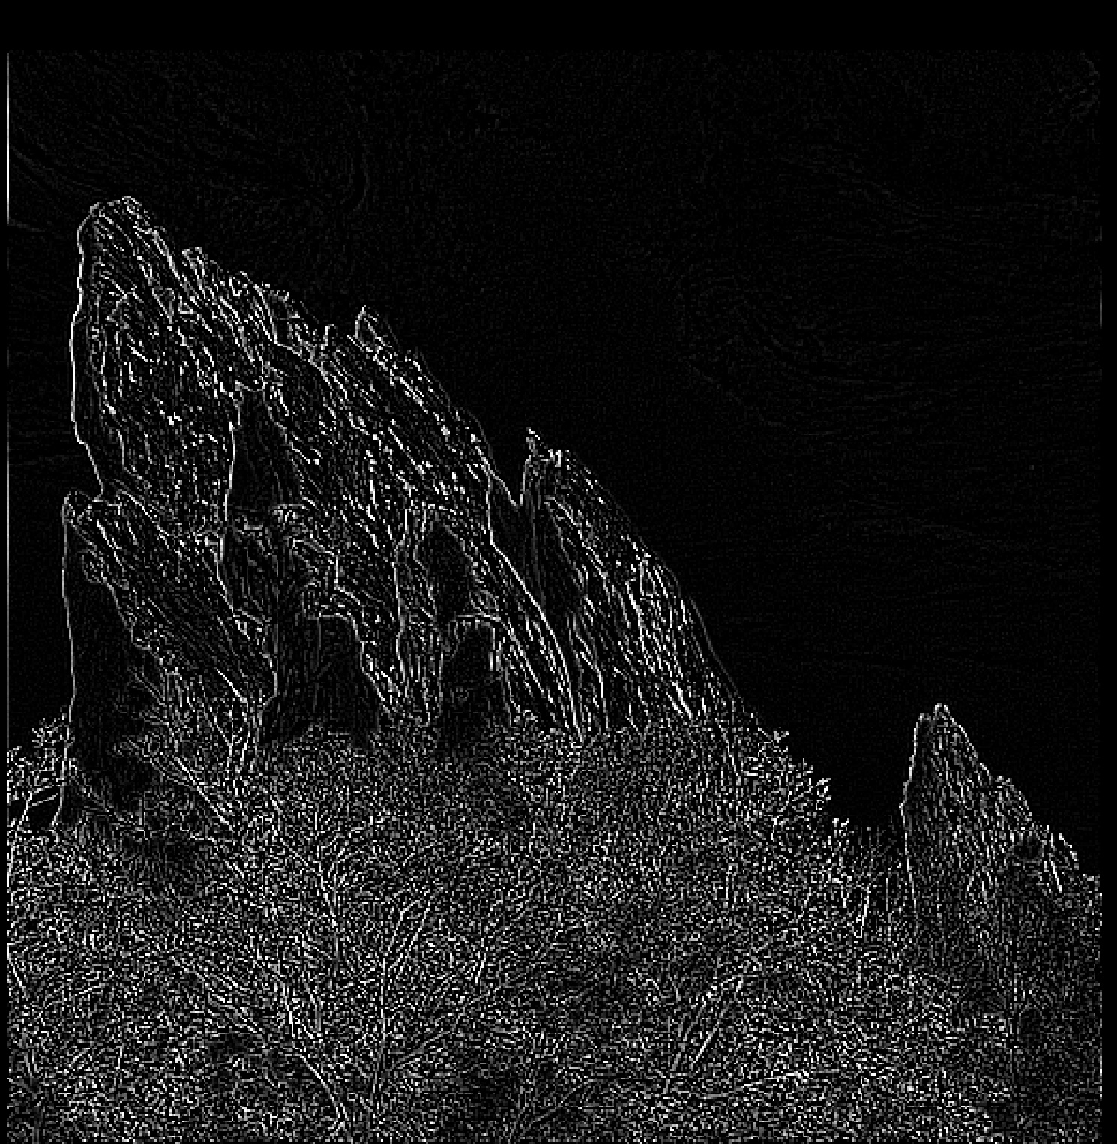 

Output image from accelerator (left) output image from simulation (right)

The accelerator takes 2.665 ms (reported at 0.002665)